CHEMISTRY CP FINAL EXAM REVIEW DUE DATE_________ Name:

Chapter 11- Chemical Reactions

- For each reaction below: identify the reaction type, predict the products and write the complete balanced reaction:
Synthesis Decomposition Single Replacement

Double Replacement Combustion

__________________ a. iron (III) hydroxide → iron (III) oxide and water

_____________________________________________________________

__________________ b. ethylene (C₂H₄) burns in pure oxygen →

___________________________________________________________

__________________ c. magnesium + nitrogen →

____________________________________________________________

2. Complete and balance the reactions below in the space provided.

_____KOH + _____ Pb(NO₃)₂ → _____ Pb(OH)₂ + _____ KNO₃

_____ Cl₂ + _____NaBr → ___________________________________________

Chapter 12- Stoichiometry

3. Sodium reacts with calcium chloride to produce sodium chloride and calcium metal.
a. Balance ____Na + ____CaCl₂ → ____Ca + ____NaCl

b. If 43.0g of calcium chloride reacts, how many grams of sodium chloride will be produced?
(ans: 45.3g NaCl)

c. The reaction above is performed in lab, and 40.0g of sodium chloride are collected. Determine the percent error and the percent yield. (ans: 88.3%)

4. Sodium sulfate reacts with aluminum bromide.
a. Balance: _____ Na₂SO₄ + ____ AlBr₃ → _____NaBr + _____Al₂(SO₄)₃

b. Predict the mass of aluminum sulfate that will form if 25.0g of sodium sulfate react with 60.0g of
aluminum bromide. (ans: 20.1g Al₂(SO₄)₃)

c. The limiting reactant is: _______________________________________.

5. Hydrogen reacts with nitrogen to produce ammonia (NH₃). If 4.4 liters of ammonia are produced at STP, how many grams of hydrogen reacted? (ans: 0.59g H₂)

N_{2(g)} + 3H₂ → 2 NH_{3(g)}

Chapter 13- States of Matter

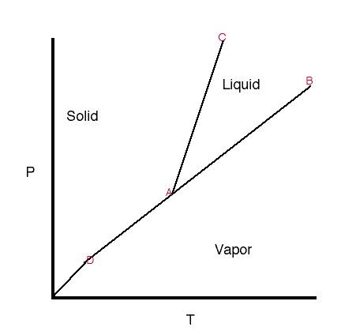
8. Use the phase diagram below to identify: a) the triple point b) the normal boiling point c) the state of the substance at 0.5atm and 25°C and d) the change that occurs as the substance is heated from 25°C to 100ºC at 0.5atm.
0.5atm
1 atm
25 50 75 100
ºCelsius

9. List 2 ways water could be made to boil at 105°C:

a. ___________________________________________________________________________
b. ___________________________________________________________________________

22. Determine the volume of oxygen gas that required for the complete combustion of 25.0g of methane gas (CH₄) at STP (ans: 69.82L O₂)

RXN: _________________________________________________________________________

28. List one similarity and three differences between boiling and evaporation.

29. Define “colligative property”:

30. Describe the effect that a solute has on the boiling point, freezing point and vapor pressure of the solvent:

boiling point –

freezing point –

vapor pressure –

Chapter 15/16- Water and Solutions

23. Complete the table below describing the solubility of each solute.

SOLUTE | Soluble in gasoline? | Soluble in alcohol? | Soluble in water?
CBr₄
KBr
CH₂O
SiO₂

24. Define hydrogen bonding:

25. Circle each of the molecules below that would exhibit hydrogen bonding:

- HF b. CH₂O c. NH₃ d. CH₄ e. H₂

26. List four properties of water that are influenced by its strong hydrogen bonds.

b.

c.

d.

27. Use the graph to answer the questions below:

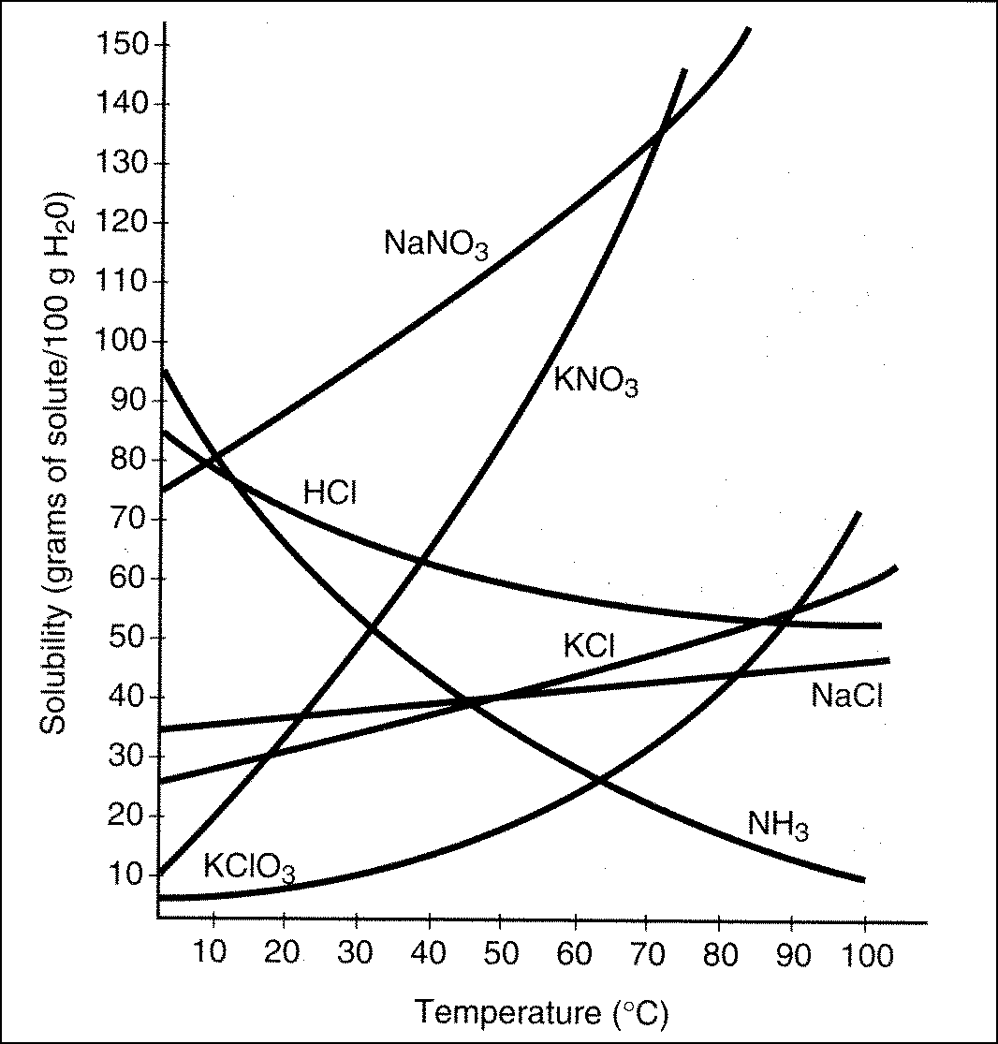

- How many grams of KClO₃ need to dissolve in 50 g of water in order to have a saturated solution at 70°C? ____________

- Which substance is the most soluble in water at 0°C? _____________

- Which substance is least affected by temperature change? _____________

- Which substance is the least soluble in water at 0°C? ______________

- Which substance becomes less soluble as the temperature increases? ____________

- How would you describe the level of saturation of a solution of KNO₃ at 40°C if there are about 60g of KNO₃ in 100g of water? ____________

30. Fill in the blanks of the following paragraph:

Word bank: pressure, temperature, concentration, high, low, solvent, solute

Molarity, percent by mass and volume express __________________ of a solution. In order to dilute a solution more of a ________________ can be added. In order to make more concentrated solution more of a _______________ can be added.
Gases are most soluble in liquids under conditions of _____________________ pressure and ___________________ temperature.

31. Determine the molarity of a solution prepared by dissolving 15.0g of KCl in 525ml of water. (ans: 0.383M)

Hint: Formula:

32. How many grams of KCl are needed to prepare a 0.25 liters of a 3.0 M solution? (ans: 56g KCl)

Hint: Rewrite the molarity as:

33. What volume of 4.0M KCl solution is needed to prepare 750.0mL of a 0.33M solution? What volume of water would also be needed? (ans: 62mL KCl solution, 688mL H₂O)

Hint: Formula:

34. What volume of 2.5M hydrochloric acid is needed to react with 32.5g of aluminum? (ans: 1.4L)

RXN: ___________________________________________________________________________

35. What volume of isopropyl alcohol is in 325mL of a 75.0% isopropyl alcohol/water solution? (ans: 244mL)

36. Find the mass percent of sodium chloride in a mixture containing 45.0g of sodium chloride in 255g of water. (ans: 15.0%)

39. What is the difference (in terms of energy) between water at 100°C and steam at 100°C?

40. Exothermic reactions ________________ (absorb/ release) heat; endothermic reactions _________________ (absorb/ release) heat.

Chapter 17 Themodynamics

41. A student is heating up sodium carbonate in order to decompose it according to following reaction:
Na₂CO_{3 (s)} → Na₂O _{(s)} + CO_{2 (g)}

Predict signs of ∆ H and ∆S for this process. ∆ H = _____ ∆ S = _____

Under what temperature conditions will this reaction be spontaneous? _____________________

42. Predict signs of ∆S for each process:

- NaCl (s) à Na⁺(aq) + Cl⁻ (aq). ∆ S = _____

- FeCl_{2(aq)} + H₂SO_{4(aq)} → FeSO_{4(s)} + HCl_{(aq)} ∆ S = _____

- Salt dissolving in water ∆ S = _____

- Condensation forming on the outside of a cold glass of water ∆ S = _____

43. Given the diagram below, determine the: (include units)
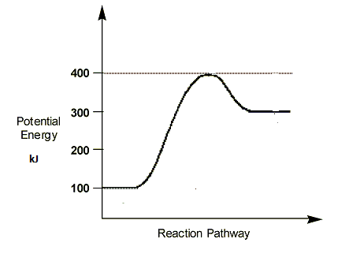
a. Enthalpy of the reactants_______________

b. Enthalpy of the products_______________

c. Heat of the reaction, ΔH. ________________

- Activation energy of the reaction. _____________

- Exothermic or Endothermic? . ___________________

Chapter 17 Themochemistry

44. The data below refers to substance X.
Melting point | Boiling Point | Heat of Fusion | Heat of Vaporization | Specific Heat Capacity (solid) | Specific Heat Capacity (liquid) | Specific Heat Capacity (vapor)
2.0°C | 52.5°C | 275 J/g | 1240 J/g | 0.90 J/gºC | 1.6 J/gºC | 0.55 J/gºC

- Draw a heating curve for substance X, going from -10ºC to 70ºC on the axis below. Write in all formulas used to calculate heat. Label the phase present at each stage of your graph. Also label changes in potential and kinetic energy.

a.. Calculate the amount of heat needed to raise the temperature of 15g of this substance from 54.0°C to 67.3°C.
(ans: 109.7J)

b. What mass of X can be heated from 20.0°C to 35.0°C using 4000J of heat.
(ans: 167g X)

45. The specific heat of aluminum is 0.910J/gºC. A student heats a sample of aluminum to 123°C and places it in a calorimeter containing 150. g of water at 23.0ºC. The final temperature of the system is 43.0ºC. What was the mass of the aluminum sample? (ans: 172g)
 | METAL | WATER
Mass
specific heat
T_{i}
T_{f}
∆T

46. Equal mass of each substance below absorbs 1000J of heat, which would become the hottest? Why?
Substance | Specific Heat Capacity
aluminum | 0.897 J/g°C
iron | 0.454 J/g°C
lead | 0.130 J/g°C

Chapter 19: Acids/Bases
47. What is the pH of a solution that has a concentration of [H⁺] = 1.0 X 10⁻⁶M? ________
Is this solution acidic, basic, or neutral? ___________________

48. What is the pH of a solution that has a concentration of [OH⁻] = 1.0 X 10⁻¹³M? _________
Is this solution acidic, basic, or neutral? ___________________

49. Complete the following table:
Property | Acids | Bases
Definition
Taste
Touch
Reaction with metals
Electrical conductivity
Reaction with indicators
(Phenolphthalein & litmus)
2 examples of strong

50. If 25 mL of 1.5 M of HCl is required to completely neutralize 35 mL of NH₄OH, what is the concentration of the ammonium hydroxide? (ans: 1.1M)

51. How many mL of 0.5 M NaOH is needed to neutralize 16 mL of a 0.35 M H₂SO₄? (ans: 22.4mL)

52. Find the mass of 1.50 moles of dicarbon tetrachloride.

53. How many molecules are in 14.0 g of dicarbon tetrachloride.

Review: Lab Equipment

58. Identify and give the use for each piece of lab equipment below:

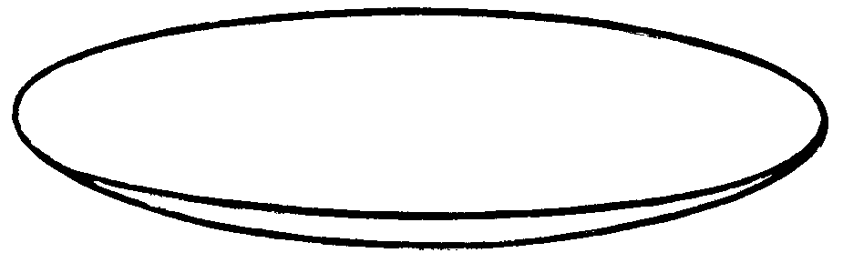 | 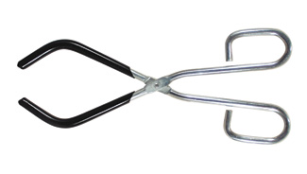
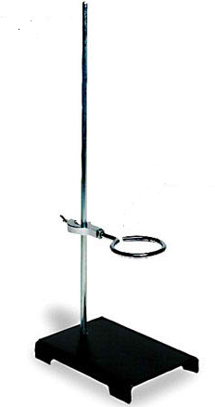 (name both items!) | 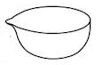
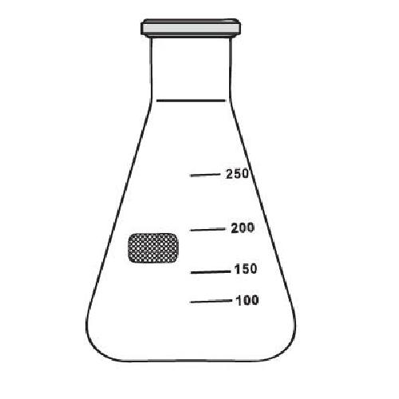 | 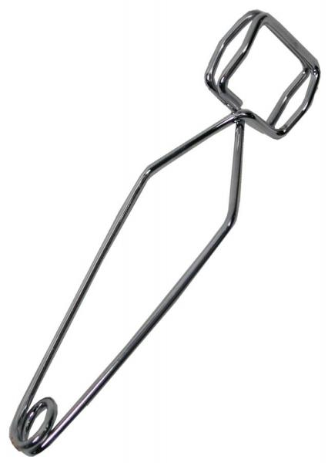
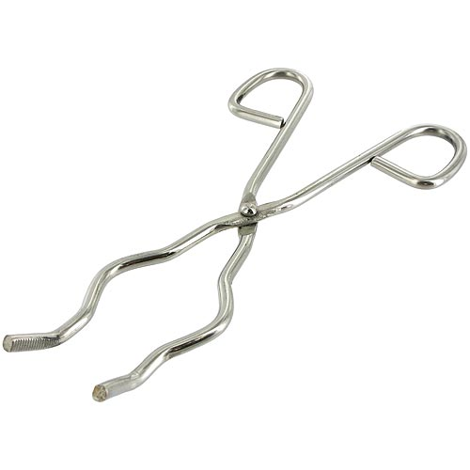 | 